Entry Form for

PHOTOGRAPHIC COMPETITION

FOR 2022 CALENDAR
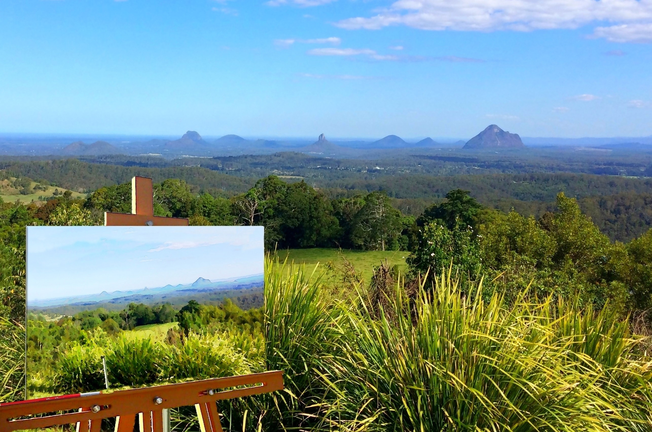
Photographer Tony Allison
Photographer Lenore Crawford
Sponsored by the Rotary Club of Maleny

APPLICATION FORM FOR ENTRIES
Photographs of Maleny and the Hinterland area that reflect scenery, events, iconic features, hinterland life and hinterland lifestyle.

Conditions of Entry

- Entries in landscape format (200x300mm) print & 1MB minimum size
- Entry photo to have separate sheet for each photo with details of location and title
- A limit of five (5) entries per photographer
- Winning entries will be informed to also provide a digital file of the entry.
- Entrants acknowledge the right of the Rotary Club of Maleny to use the photos in the Rotary Calendar and for
Calendar publicity, where recognition of the photographer will be made.
- Entries to be delivered to Maleny Newsagency, Maple Street, Maleny by the closing date of Friday 11th June 2021.
- Judging to take place Saturday 19th June 2021

Prizes

The prizes will total $1400 and will be allocated as follows:
- $500 for 1st
- $250 for 2nd
- $150 for 3rd
- $50 gift voucher from Maleny IGA for each of the other 10 entries chosen for display in the calendar

Photographer’s Name __________________________________________

Address __________________________________________

Contact phone number __________________________________________

Email address __________________________________________

Details of location & subject __________________________________________

Caption for photo __________________________________________

I confirm that the photograph accompanying this form is my own work.

Signature Date / /
__________________________________________
Rotary Contact – Lionel Tilley 5429 6629
e. jude3me@bigpond.com
Photographer Laurelle Owen

